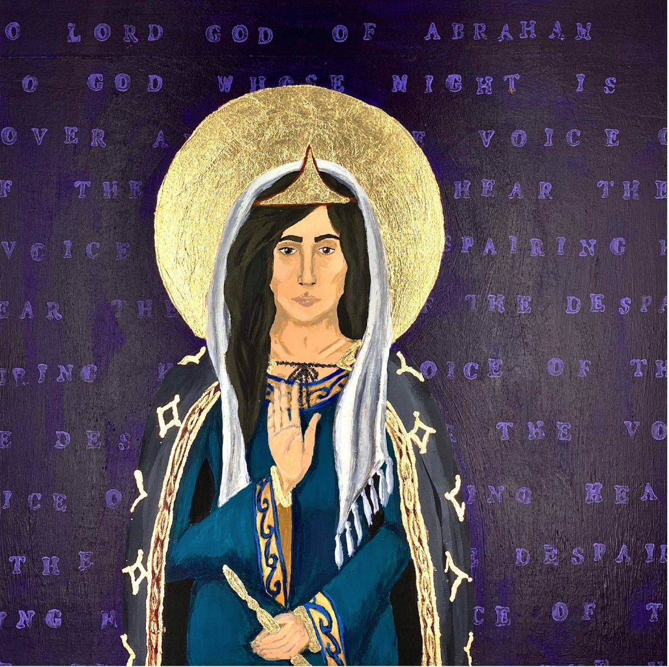

Esther by Charlotte Gibson

Proper 10B – 7th Sunday after Pentecost
14 July 2024

PRELUDE MUSIC Hank Curtis

PRELUDE MEDITATION Hank Curtis

PROCESSIONAL

O God of every nation Blue Hymnal 607
Music: “Foundation,” from The Sacred Harp, 1844
Words: K., in John Rippon’s Selection, 1787

- How firm a foundation, ye saints of the Lord,
is laid for your faith in his excellent word!
What more can he say than to you he hath said,
to you that for refuge to Jesus have fled?

- Fear not, I am with thee; O be not dismayed!
For I am thy God, and will still give thee aid;
I’ll strengthen thee, help thee, and cause thee to stand,
upheld by my righteous, omnipotent hand.

- When through the deep waters I call thee to go,
the rivers of woe shall not thee overflow;
for I will be with thee, thy troubles to bless,
and sanctify to thee thy deepest distress.

- When through fiery trials thy pathway shall lie,
my grace, all sufficient, shall be thy supply;
the flame shall not hurt thee, I only design
thy dross to consume, and thy gold to refine.

- The soul that to Jesus hath fled for repose,
I will not, I will not desert to its foes;
that soul, though all hell shall endeavor to shake,
I’ll never, no, never, no, never forsake.

OPENING ACCLAMATION

Pōmaikaʻi ke Akua: Ka Makua, ke Keiki, a me ka ʻUhane Hemolele.
Blessed be God: Father, Son, and Holy Spirit.
And blessed be God’s kingdom, now and for ever. Amen.

THE GLORIA Blue Hymnal S-280

Glory to God in the highest, and peace to his people on earth.
Lord God, heavenly King, almighty God and Father,
we worship you, we give you thanks, we praise you for your glory.

Lord Jesus Christ, only Son of the Father, Lord God, Lamb of God,
you take away the sin of the world; have mercy on us;
you are seated at the right hand of the Father; receive our prayer.

For you alone are the Holy One, you alone are the Lord,
you alone are the Most High, Jesus Christ, with the Holy Spirit,
in the glory of God the Father. Amen.

COLLECT OF THE DAY

E noho pū ka Haku me ʻoukou. The Lord be with you.
And also with you.
E pule kākou. Let us pray.
O Lord, mercifully receive the prayers of your people who call upon you, and grant that they may know and understand what things they ought to do, and also may have grace and power faithfully to accomplish them; through Jesus Christ our Lord, who lives and reigns with you and the Holy Spirit, one God, now and for ever. Amen.

FIRST READING Esther 1:1-11

A reading from Esther

﻿﻿﻿Now it was in the days of Ahasuerus, he, Ahasuerus, ruled from India to Nubia, one hundred twenty-seven provinces. And it was in those days when King Ahasuerus inhabited his royal throne in the Susa fortress. In the third year of his reign, he gave a banquet for all his officials and servants; the army of Persia and Media and the nobles and governors of the provinces came before him. When he displayed the glorious riches of his kingdom and the exquisite beauty of his majesty, it was many days, one hundred eighty days.

And when these days were completed, the king gave for all the people who could be found in the fortress, Susa, great and small, a banquet lasting for seven days in the court of the garden of the palace of the king. And there were white linen and royal blue [hangings] held up with cords of fine linen and purple on silver rings and alabaster columns; there were reclining-couches of gold and silver on a pavement of porphyry, alabaster, mother-of-pearl, and colored stones. And there were drinks in golden vessels, vessels upon vessels of different kinds, and there was abundant royal wine at the direction of the king. And the rule for the drinking was, “No restraint!” ; for thus it was established by the king for all the officials of his palace to do as each one desired. In addition, Queen Vashti gave a banquet for the women in the palace of King Ahasuerus.

On the seventh day, when the heart of the king was merry with wine, he commanded Mehuman, Biztha, Harbona, Bigtha and Abagtha, Zethar and Carkas, the seven eunuchs who served in his presence: They were to bring Queen Vashti before the king wearing the royal crown in order to show the peoples and the officials her beauty; for she was beautiful to behold.

The Word of the Lord.
Thanks be to God.

Psalm 49:5-15

A reading from Psalms.

﻿5 Why should I fear in evil days, when iniquity at my heels surround me?
6 Those who trust in their wealth and praise of the abundance of their riches?
7 Certainly, it cannot redeem a person, or can one give [it] to God as their ransom.

8 For the redemption-price of a soul is costly, they come to an end, forever.
9 Shall one should live eternally and never see the Pit?
10 For when one sees the wise, they die; the foolish and ignorant perish together and leave to others their wealth.

11 Their graves are their homes for all time, their dwelling places from generation to generation, though they put their names on lands.
12 Humanity will not recline in grandeur; rather they are like the animals that perish.

13 This is the way of the foolish, those pleased with their own words. Selah
14 Like sheep they are set for Sheol; Death shall be their shepherd. The upright shall rule over them until the morning, and their form shall waste away; Sheol shall be their abode.
15 But God will ransom my soul, for from the grasp of Sheol she will take me. Selah

Amen and Amen

SECOND READING James 5:1

A reading from James.

﻿Come now, wealthy people, weep, wail for the miseries that are coming to you all. Your riches are rotting and your clothes are moth-eaten. Your gold and silver have decayed and their decay shall be a witness against you, and it shall eat your flesh like fire. You all have laid up treasure for the last days. Listen! The wages of the workers who reaped your fields – which you all defrauded them out of – cry out and the cries of the farm workers have reached the ears of the Commander of heaven’s legions. You all have lived on the earth in self-indulgence and in luxury; you all have gorged your hearts in a day of slaughter. You all have condemned, murdered, the righteous one. Does not God resist you?

The Word of the Lord.
Thanks be to God.

THE GOSPEL Mark 10:17-31

Ka ʻEuanelio hemolele o ko kākou Haku, ʻo Iesu Kristo ma Mareko.
The Holy Gospel of our Lord Jesus Christ, according to Mark.
Glory to you, Lord Christ.

As Jesus went out the road a person ran to him and knelt before him and asked him, “Good Teacher, what must I do in order to inherit eternal life?” An Jesus said to the person, “Why do you call me good? No one is good but God alone. The commandments you know:

You shall not murder;
You shall not commit adultery;
You shall not steal;
You shall not bear false witness;
You shall not defraud;
Honor your mother and your father.”

Then the person said to him, “Teacher, all these have I kept from my youth.” And then Jesus, looking at the person, loving them, said, “One thing you lack; go, sell what you have, and give to the poor and you will have treasure in heaven and come, follow me.” Now the person was shocked at this word and went away grieving, for the person had many possessions.

Then looking around Jesus said to his disciples, “How hard it will be for those who have wealth to enter the majesty of God!” And the disciples were astounded at these words. So Jesus spoke to them again, “Children, how hard it is to enter the majesty of God! It is easier for a camel to go through the eye of a needle than for a rich person to enter the majesty of God. And they were amazed all the more and said among themselves, “Who then can be saved?” Jesus looked at them and said, “For the woman-born it is impossible, but not for God; all things are possible for God.”

Peter began to speak to him, “Look! We have left everything and followed you.” Jesus said, “Truly I tell all of you, there is no one who has left house or sisters or brothers or mother or father or children or fields, for my sake and for the sake of the gospel, who will not receive a hundredfold now in this age: houses, sisters and brothers [or friends and kin], mothers and children, and fields with persecutions and, in the age to come, eternal life. But many who are first will be last, and the last will be first.”

Ka ʻEuanelio o ka Haku. The Gospel of the Lord.
Praise to you, Lord Christ.

THE SERMON Fr. Wil Gafney

MUSICAL RESPONSE Hank Curtis

PRAYERS OF THE PEOPLE

In peace and in faith, let us offer our prayers, saying “E ka Haku, e aloha mai” (“Lord, have mercy”). (A brief silence)

For peace and tranquility in the world, and for the salvation of all. We pray for your church in all the world. Lord, have mercy.
E ka Haku, e aloha mai.

For the Church of God in every place and all who minister worldwide, and especially our Episcopal and Anglican sibling churches beyond this island: For the clergy and people of the Anglican Church in Central America; and the clergy, staff, congregation, families, and community of St. Mary's and St. Peter's. Lord, have mercy.
E ka Haku, e aloha mai.

For Michael, our Presiding Bishop; for Bob, our own Bishop; for Wil, our visiting supply clergy; for our sibling Episcopal congregations on Kauaʻi: St. John and St. Paul, West Kauaʻi; St. Michael & All Angels, Līhuʻe; and Christ Memorial, Kilauea; and our own congregation of All Saints – those present, online, and absent – that all of us together may be united in your ministry and that we all may be one. Lord, have mercy.
E ka Haku, e aloha mai.

For the good earth graciously given by our Creator; for the care of our global environment; and for the wisdom and will to conserve it for your glory and for the blessing of all. Lord, have mercy.
E ka Haku, e aloha mai.

For those who serve in government and industry, that they may make decisions with wisdom, compassion, and dignity. We pray against the use of violence of any kind, and ask that your healing balm of peace and mutual respect would hold sway over our land. Lord, have mercy.
E ka Haku, e aloha mai.

For the sick and suffering in body, mind, and spirit, we pray for those we name silently or aloud. (Brief silence) Lord, have mercy.
E ka Haku, e aloha mai.

For all who have died in the faith, that you would bring them into your glorious presence. We commend to your loving care those we name silently or aloud. (Brief silence) Lord, have mercy.
E ka Haku, e aloha mai.

Rejoicing in the fellowship of the ever-blessed Virgin Mary and St. Joseph, King Kamehameha IV and Queen Emma, Queen Lili‘uokalani and all the saints, let us commend ourselves, and one another, and all our life to Christ our God.
Ho‘omaika‘i iā e ka Haku. (Praise to you, O Lord.)

THE QUEEN’S PRAYER Queen Lili‘uokalani

- ‘O kou aloha nō, - Aia i ka lani,
A ‘o kou ‘oiaʻiʻo, he hemolele hoʻi.
(Your love is in Heaven, and your Truth – so perfect.)

- Koʻu noho mihi ‘ana, A paʻahao ‘ia,
‘O ‘oe kuʻu lama, kou nani koʻu koʻo.
(I live in sorrow, imprisoned; you are my light, my support.)

- Mai nana ‘inoʻino, Na hewa o kanaka,
Aka, e huikala, A maʻemaʻe no.
(Behold not with malevolence human sins, but forgive and cleanse.)

- No laila e ka haku, Ma lalo kou ‘eheu
Ko makou maluhia, A mauloa aku no. ‘Āmene.
(And so, O Lord, beneath your wings be our peace forevermore. Amen.)

THE PEACE

The Peace of the Lord be always with you.
And also with you.

ANNOUNCEMENTS

OFFERTORY ANTHEM Hank Curtis

“Iesu Me Ke Kanaka Wai Wai” “Jesus and the rich young ruler”
words traditional, music by John K. Almeida

Ma ke alahele ʻo Iesû
I hālāwai aku ai
Me ke kanaka ʻōpio hanohano
Kaulana i ka waiwai
Pane mai e ka ʻōpio
ʻE kuʻu Haku maikaʻi
He aha hoʻi kaʻu e hana aku ai
I loaʻa e ke ola mau?

Hui:
E hāʻawi, e hāʻawi lilo
I kou mau waiwai
Huli a hahai mai iaʻu
I loaʻa e ke ola mau ia ʻoe

Minamina e ka ʻōpio
I kona mau waiwai
I ke kūʻai a hāʻawi lilo aku
I ka poʻe nele a hune
Huli aʻe ʻo Iesū lā
Pane aku i ka ʻōpio
ʻAʻole aʻe hiki ke kanaka waiwai
I ke aupuni o ka lani

Hui:
E hāʻawi, e hāʻawi lilo
I kou mau waiwai
Huli a hahai mai iaʻu
I loaʻa e ke ola mau ia ʻoe

HAWAIIAN DOXOLOGY

Ho‘onani i ka Makua mau, Ke Keiki me ka ‘Uhane nō,
Ke Akua mau ho‘omaika‘i pū, Ko kēia ao, ko kēlā ao. ‘Āmene.

THE HOLY COMMUNION

The Lord be with you.
And also with you.
Lift up your hearts.
We lift them to the Lord.
Let us give thanks to the Lord our God.
It is right to give God thanks and praise.

We praise you and we bless you, holy and gracious God, because you are the source of life and light. You made us in your image, and called us to new life in Jesus Christ our Lord. And so this day, we join with Saints and Angels in the chorus of praise that rings through eternity, lifting our voices to magnify you as we say/sing:

SANCTUS Blue Hymnal S-129

Holy, holy, holy, Lord, God of power and might:
Heaven and earth are full of your glory. Hosanna in the highest!
Blessed is He who comes in the name of the Lord.
Hosanna in the highest!
Glory and honor are yours, Creator of all. You called us as your people to look to your Son, who was tempted in every way as we are, yet did not sin. By his grace we are able to triumph over every evil, and to live no longer for ourselves alone, but for him who died for us and rose again.
Loving God, accept these gifts of bread and wine, which are already the Body and Blood of our Lord Jesus Christ. As we receive these gifts, make us aware of his self-offering, and use them to strengthen us to live for your glory and for the blessing of those around us.
Giver of Life, draw us together in the Body of Christ, and in the fullness of time gather us with the Virgin Mary and St. Joseph, King Kamehameha IV and Queen Emma, Queen Lili‘uokalani and all saints, into the joy of our true eternal home.
Through Christ and with Christ and in Christ, by the inspiration of your Holy Spirit, we worship you, our God and Creator, in voices of unending praise. Amen.
And now, as our Savior Christ has taught us, we are bold to say:

Our Father, who art in heaven, hallowed be thy Name,
thy kingdom come, thy will be done, on earth as it is in heaven.
Give us this day our daily bread.
And forgive us our trespasses, as we forgive those who trespass against us.
And lead us not into temptation, but deliver us from evil.
For thine is the kingdom, and the power, and the glory,
for ever and ever. Amen.
God of promise, you have prepared a banquet for us. Happy are those who are called to the Supper of the Lamb!
The Gifts of God for the People of God. Let us take them in remembrance that Christ died for us, and let us feed on him in our hearts by faith, with thanksgiving.

COMMUNION MUSIC Hank Curtis

POST-COMMUNION PRAYER
Loving God, we give you thanks for restoring us in your image
and nourishing us with spiritual food
in the Sacrament of Christ’s Body and Blood.
Now send us forth: a people forgiven, healed, renewed;
that we may proclaim your love to the world
and continue in the risen life of Christ our Savior. Amen.

THE BLESSING

Ka hoʻopōmaikaʻi ʻana o ke Akua mana loa – ka Makua, ke Keiki, a me ka ʻUhane – me ʻoukou a e noho pū me ʻoukou a mau loa aku. ʻĀmene.

The blessing of God Almighty – the Source, the Son, and the Spirit – be upon you and remain with you for ever. Amen.

THE RECESSIONAL

God of Grace and God of Glory Blue Hymnal 594
Music: “Cum Rhondda,” John Hughes
Words: Harry Emerson Fosdick

- God of grace and God of glory, on thy people pour thy power;
crown thine ancient Church’s story; bring her bud to glorious flower.
Grant us wisdom, grant us courage, for the facing of this hour,
for the facing of this hour.

- Lo! The hosts of evil round us scorn thy Christ, assail his ways!
From the fears that long have bound us free our hearts to faith and praise: grant us wisdom, grant us courage for the living of these days,
for the living of these days.

- Cure thy children’s warring madness, bend our pride to thy control;
shame our wanton, selfish gladness, rich in things and poor in soul.
Grant us wisdom, grant us courage, lest we miss thy kingdom’s goal,
let we miss thy kingdom’s goal.

- Save us from weak resignation to the evils we deplore;
let the gift of thy salvation be our glory evermore.
Grant us wisdom, grant us courage, serving thee whom we adore,
serving thee whom we adore.

THE DISMISSAL

E hele aku ʻoukou me ka maluhia e aloha a e mālama i ke Akua: Aleluia, aleluia!
Go in peace, to love and serve our God: Alleluia, alleluia!
Thanks be to God. Alleluia, Alleluia, Alleluia!

POSTLUDE Hank Curtis

